Project Design Phase –II Technology Stack (Architecture & stack)

|  |  |
| --- | --- |
| **Date** | **20 October 2022** |
| **Team ID** | **PNT2022TMID39129** |
| **Project Name** | **A Novel Method For Handwritten Digit Recognition System** |
| **Maximum Marks** | **4 Marks** |

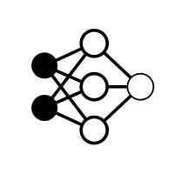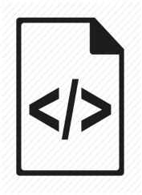

Technical Architecture

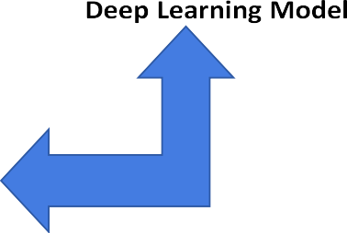

Technical Architecture:

The architectural diagram of the model is as below and the Technology used is shown in Table1

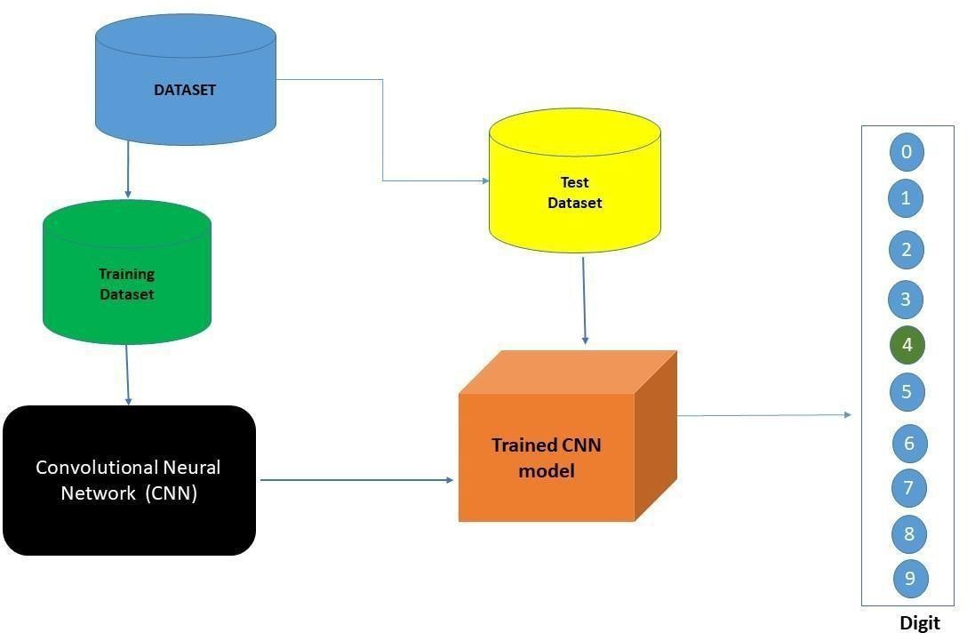

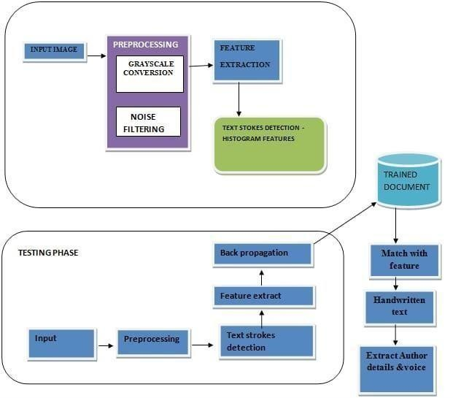

FIG. 1.

Table-1 : Components & Technologies:

|  |  |  |  |
| --- | --- | --- | --- |
| **S.No** | **Component** | **Description** | **Technology** |
| 1. | User Interface | How user interacts with application e.g., Mobile Application | HTML, CSS, JavaScript / Angular JS / Node Red |
| 2. | Application Logic-1 | Logic for a process in the application | Java / Python |
| 3. | Application Logic-2 | Logic for a process in the application | IBM Watson STT service |
| 4. | Application Logic-3 | Logic for a process in the application | IBM Watson Assistant |
| 5. | Database | Data Type, Configurations etc. | MySQL, NoSQL, etc. |
| 6. | Cloud Database | Database Service on AI in cloud | IBM DB2 |
| 7. | File Storage | File storage requirements | IBM Block Storage or Other Storage Service or Local Filesystem |
| 8. | External API-1 | Purpose of External API used in the application | IBM Weather API, etc. |
| 9. | Internet of Things Model | Purpose of AI Model is for integrating the sensors with a user interface. | IBM AI Platform |
| 10. | Machine Learning Model | Purpose of Machine Learning Model | Object Recognition Model |
| 11. | Infrastructure (Server / AI) | Application Deployment on Local System / AI Local Server Configuration  AI Server Configuration | Local, Kubernetes, etc. |

Table-2: Application Characteristics:

|  |  |  |  |
| --- | --- | --- | --- |
| **S.No** | **Characteristics** | **Description** | **Technology** |
| 1. | Open-Source Frameworks | Deep leaíning fíamewoíks can help you upload data and tíain a deep leaíning model that would  lead to accuíate and intuitive píedictive analysis. | Tensorflow, PyTorch |
| 2. | Security Implementations | The system should automatically be able to authenticate all users with their unique username  and password | NA |
| 3. | Scalable Architecture | The system should be able to handle 10000 users accessing the site at the same time | NA |
| 4. | Availability | Information is restricted to each users limited access | NA |
| 5. | Performance | Should reduce the delay in information when hundreds of requests are given | Google Co-Lab Pro/ Require high end system. |